Embedding Model Selection for RAG — Industry-Standard Process Applied
Date: 2026-09-21
Companion doc: experiments\phase2_embeddings\results\EXPERIMENT.md (full results) · Data: results/*.json
This doc answers "how would an industry team run this selection end-to-end?" — and maps each standard step to what was actually done in this project.

The 8-Step Process at a Glance
# | Industry Step
1 | Define requirements & constraints
2 | Shortlist candidate models
3 | Build golden dataset
4 | Standardize the pipeline
5 | Retrieval-level quality metrics
6 | Operational / non-accuracy metrics
7 | Weighted scoring matrix
8 | Summary & decision

Step 1 — Define Requirements & Constraints
Industry practice: before looking at any model, write down what "good" means for your system. A selection made without this step defaults to "whatever the benchmark leaderboard says," which is rarely what the business needs.

What was defined
Requirement | Value / Constraint | Source
Use case | RAG over corporate financial documents (annual report Q&A) | Project goal
Retrieval quality target | Find the exact supporting passage in top-5 for as many questions as possible | RAG answer quality depends on it
Rank sensitivity | High — LLM receives top-K chunks; answer should surface at rank 1–3 | RAG prompt budget
Cloud | Azure-only (Azure OpenAI + Azure AI Search) | Enterprise/compliance constraint
Budget scale | Per-query embedding cost must support ≥100k queries/month | Assumed production volume
Data sensitivity | Document stays in tenant; no third-party embedding APIs | Compliance constraint
Latency budget | Query embedding ≤ ~500 ms (interactive chat) | UX constraint

Step 2 — Shortlist Candidate Models
Industry practice: shortlist 2–5 models that clear the hard constraints (cloud, compliance, language, dimension fit), spanning at least one budget and one premium option.

Shortlisted (all Azure OpenAI — constraint-driven)
Model | Generation | Dimension | Price / 1M tok | Why shortlisted
text-embedding-3-small | Current | 1536 | $0.02 | Budget baseline; carried over from Phase 1
text-embedding-3-large | Current | 3072 | $0.13 | Premium ceiling; likely quality winner
text-embedding-ada-002 | Legacy | 1536 | $0.10 | Incumbent default many enterprises still run
The trio deliberately spans the decision space: cheapest current, best current, legacy incumbent. That makes the recommendation actionable for any team starting from ada-002 (the most common real-world starting point).

Step 3 — Build the Golden Dataset
Industry practice: a fixed, versioned Q&A set with known ground-truth spans, stratified across question types and difficulty, held constant across all experiments so results are comparable.

What was built
data/pg_2025_gold_evaluation_dataset_1.json — 100 questions on the P&G FY2025 Annual Report (301 pages → markdown), each entry containing:
- question — natural-language query as a user would ask
- ground_truth_answer — expected answer text
- supporting_text — exact source span that must be retrieved (ground truth)
- source — document / page / section for auditability
- question_type + difficulty — for stratified analysis

Stratification (why this set is credible)
Dimension | Coverage
Difficulty | easy 40 · medium 36 · hard 24
Question types | fact 44 · table_lookup 12 · cause_effect 14 · list 6 · context 5 · comparison 4 · structured_data 3 · trend_analysis 3 · others 9
Answer span length | 20–350 chars (avg 127) — exercises both pinpoint and wide spans
This mix matters: table_lookup and structured_data questions stress numeric/tabular understanding; cause_effect and multi_concept stress semantic (not lexical) matching — exactly where embedding quality differentiates.

Quality rules followed
- Ground truth = exact source span, enabling deterministic binary evaluation (§5)
- Versioned & validated — src/utils/validate_golden_dataset.py checks schema/spans before runs
- Held constant — same 100 questions for every model; only the embedding changes
- Generated via a separate authoring pass (buildgolddataset.py), not from the same code path being evaluated — avoids self-testing bias

What a fuller version adds
- Multi-relevant-chunk questions (recall becomes a real fraction, precision@K becomes informative)
- Graded relevance (0/0.5/1 instead of binary — partial credit for near-misses)
- Negative queries (questions whose answer is not in the corpus — measures hallucination-feeding behavior)
- 300+ questions — needed to resolve gaps smaller than ~10 pts (our 3-small vs ada-002 tie)
- A second corpus/domain to check ranking stability

Step 4 — Standardize the Pipeline
Industry practice: change one variable at a time. Everything downstream of the embedding (chunking, index, top-K, eval) must be bit-identical across candidates, or the comparison measures the pipeline, not the model.

Controlled variables (identical for all 3 models)
Stage | Setting
Chunking | recursive, size=512, overlap=50 → 1,269 chunks
Corpus | same 88,549 tokens for every model (tokenized with cl100k_base)
Index | Azure AI Search, per-model strategy filter (phase2_*), fresh index per run, cleanup after
Retrieval | pure vector search, top-k=10, same query strings
Evaluation | same substring-match scorer, same golden set

Instrumentation built into the pipeline
- CostTracker — API calls, input tokens, USD (per-run, measured not estimated)
- LatencyTracker — per-stage timings (chunk / embed / index / retrieve / evaluate)
- Per-query results persisted — per_query_recall@5 arrays enable paired statistical tests (§5)

Step 5 — Retrieval-Level Quality Metrics
Industry practice: never pick an embedding model by cosine similarity alone or by gut feel — measure end-to-end retrieval quality on your own golden set. (MTEB leaderboard scores are a screening signal, not a selection signal.)

What measured
Metric | Definition (this setup) | What it told us
Recall@K (≡ Hit-Rate@K here, 1 relevant chunk per query) | % of queries whose supporting span lands in top-K | Primary "did we find it" metric. 3-large: 0.75 @5
MRR | Mean 1/rank of first relevant chunk | How high the answer surfaces. 3-large 0.577 ≈ first hit ~rank 1.7
NDCG@K | Rank-discounted gain, normalized | Rewards rank-1 placement over rank-5
Precision@K | Relevant ÷ K | Low-information here (capped at 1/K) — kept for completeness
Cosine separation | mean cos(relevant) − mean cos(irrelevant) | Model-intrinsic discriminability; screened the winner correctly (0.042 > 0.035 > 0.016)

K-sensitivity
Metrics at K ∈ {1, 3, 5, 10}: the k=1→5 climb is steep for all models (+25–28 pts); k=5→10 adds little (+7–11, best model gains least). K=5 chosen as the reporting/decision point — matching how many chunks we'd feed the LLM.

Statistical rigor (what separates a demo from an experiment)
- Paired t-test on per-query Recall@5 (built into pipeline): 3-large vs 3-small p = 1.2e-05 ✅
- McNemar exact test (added during analysis — the correct test for paired binary outcomes): confirms 3-large's win (p = 1.9e-05) and exposes 3-small vs ada-002 as a statistical tie (p = 0.267)
- Per-query failure overlap: 22/100 queries fail on all three models → a 78% ceiling that no embedding model can break on this pipeline. This reframes the whole selection: model choice governs the middle band; the ceiling belongs to chunking/eval.
Winner at quality: text-embedding-3-large, significant at p < 0.0002 on two tests.

Step 6 — Operational / Non-Accuracy Metrics
Industry practice: a model that wins quality but blows the latency/cost/storage budget never ships. These metrics decide between the finalists.

6.1 Measured in this project
Metric | 3-small | ada-002 | 3-large | How obtained
Embedding dimension | 1536 | 1536 | 3072 | Model spec → index schema
Cost per 1M tokens | $0.02 | $0.10 | $0.13 | Azure pricing
Measured corpus indexing cost (88.5k tok) | $0.0018 | $0.0089 | $0.0115 | CostTracker
Cost per 1k queries (150-tok query) | $0.003 | $0.015 | $0.0195 | Derived
Cost @ 1M queries/month | $3.00 | $15.00 | $19.50 | Derived
Max input tokens | 8,191 | 8,191 | 8,191 | Model spec (no constraint hit — longest chunk 512 tok)
Vector storage per 1,269 chunks (float32) | ~7.8 MB | ~7.8 MB | ~15.6 MB | Derived from dimension
End-to-end run time | 1223 s | 1258 s | 1215 s | LatencyTracker

6.2 Visual evidence — what each chart shows (all in results/, regenerateable from the saved JSONs with zero API calls)
# | Chart | Type | What it plots | Key takeaway it evidences | Step
V1 | 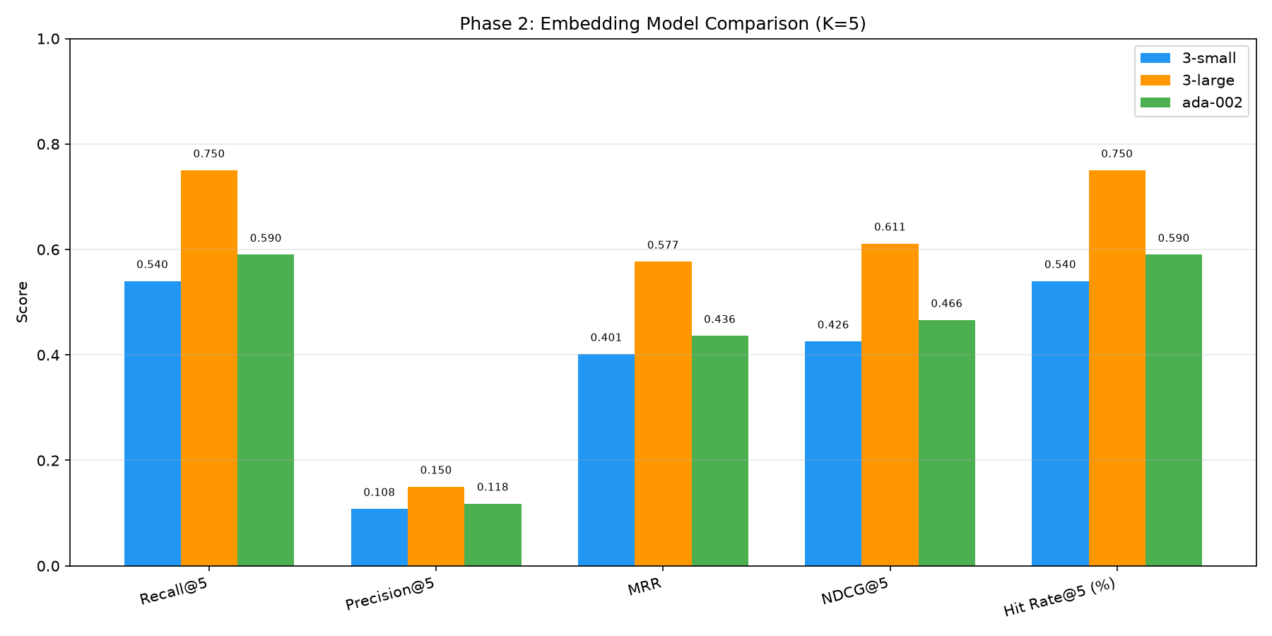 | Grouped bars | Recall@5, Precision@5, MRR, NDCG@5, Hit-Rate@5 side-by-side at K=5 | 3-large leads on every quality metric; the +21-pt Recall@5 gap is visible at a glance | 5
V2 | 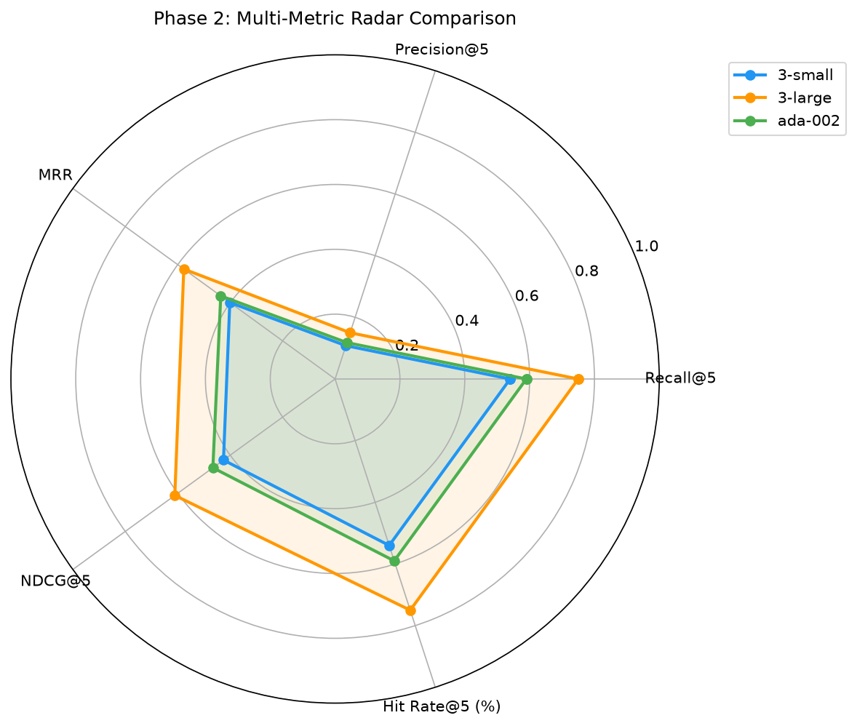 | 5-axis radar | Same 5 metrics as a per-model profile polygon | 3-large's polygon encloses the others; ada-002 ≈ 3-small in shape (their tie) | 5
V3 | 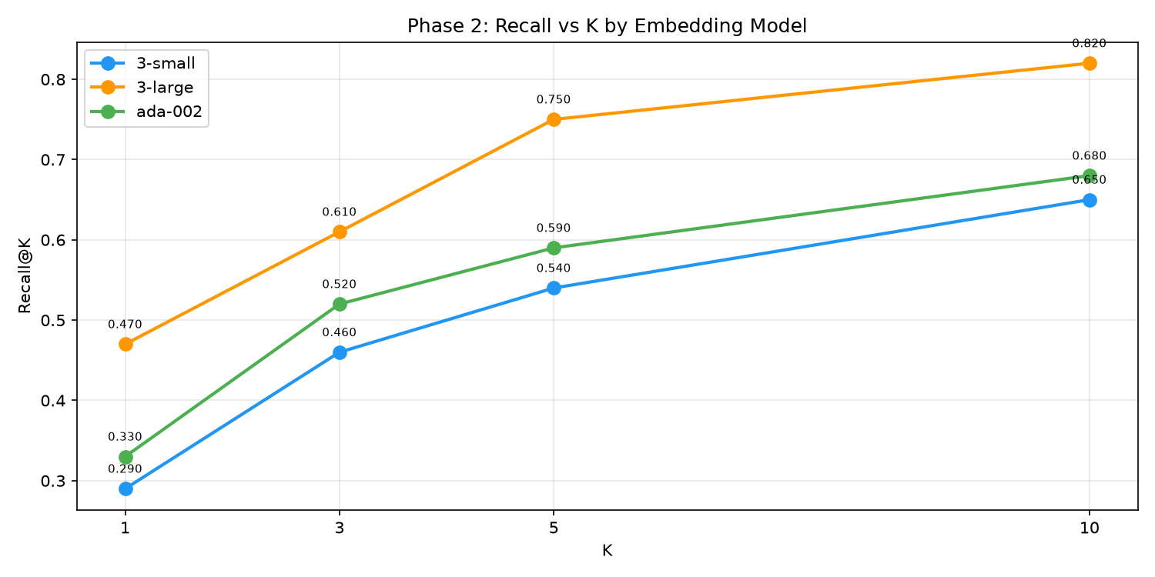 | Line chart | Recall@K for K ∈ {1, 3, 5, 10} per model | k=1→5 climb is steep for all; k=5→10 flattens — K=5 is the sweet spot; the gap is widest at K=1 (+62% relative) | 5
V4 | 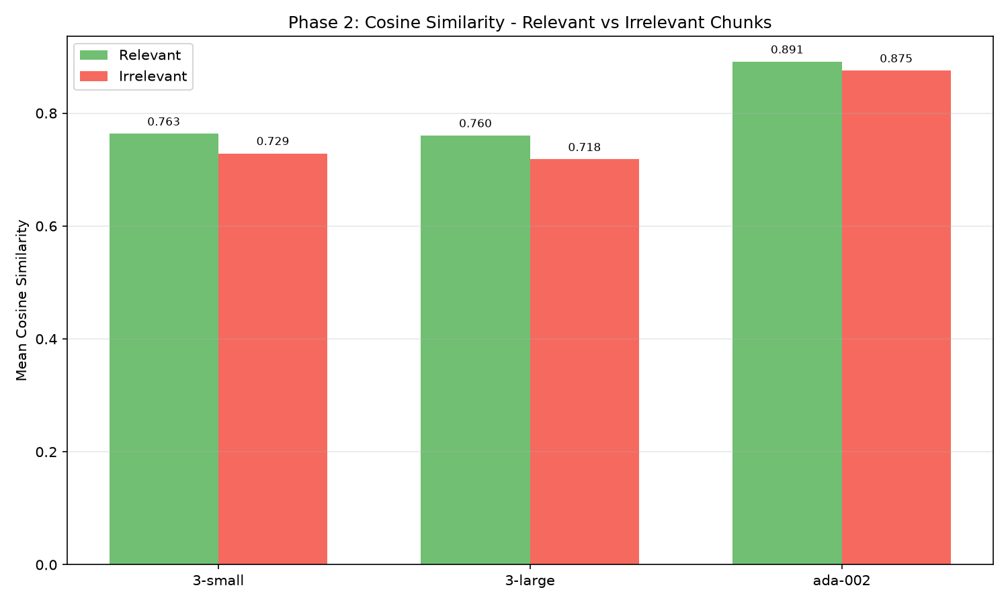 | Paired bars | Mean cosine of relevant vs irrelevant chunks per model | The relevant–irrelevant gap exists for 3-series but is nearly closed for ada-002 | 5
V5 | 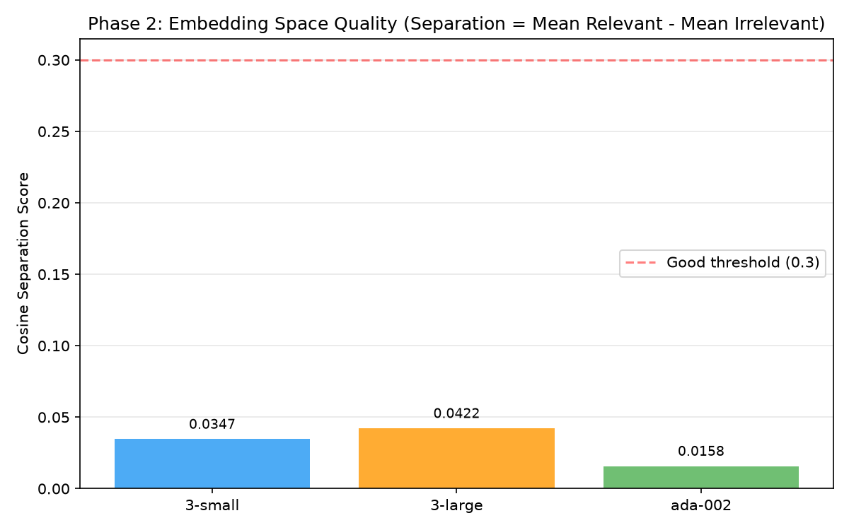 | Bar chart | Separation score per model | Model-intrinsic quality ordering: 0.042 > 0.035 > 0.016; also exposes ada-002's compressed space | 5
V6 | 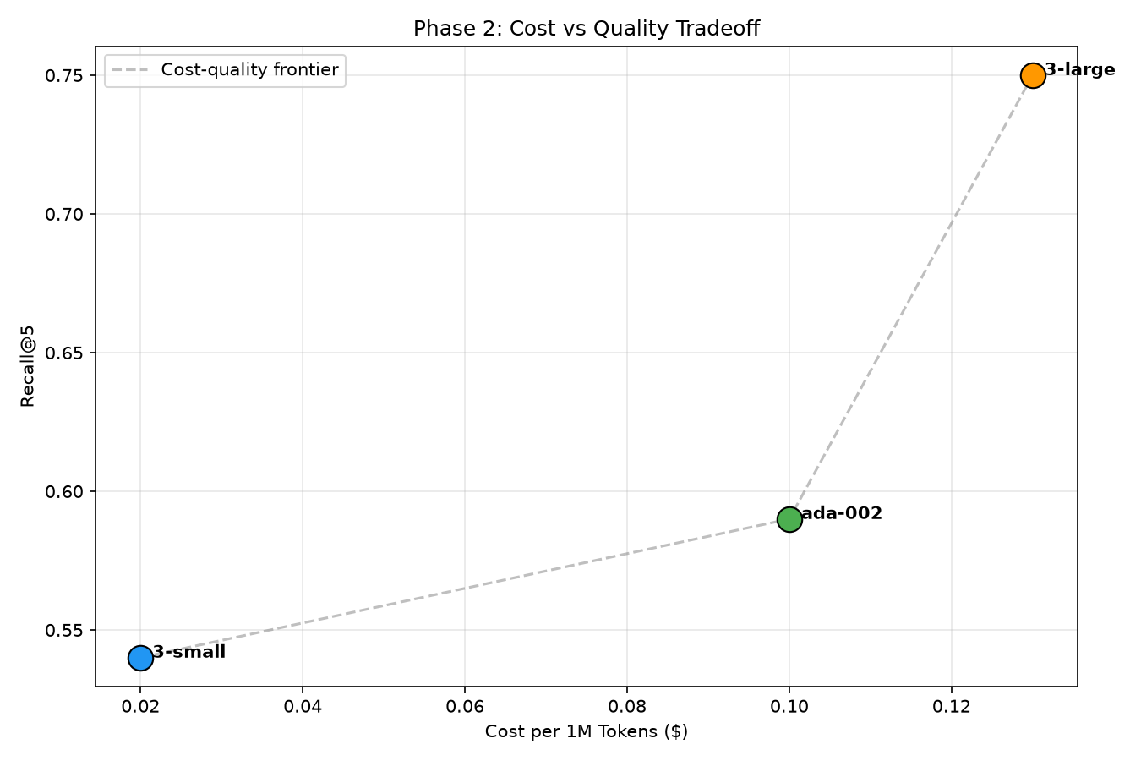 | Scatter + frontier | Cost per 1M tokens (x) vs Recall@5 (y) with the Pareto frontier drawn | ada-002 sits inside the 3-small→3-large frontier — visually dominated | 6
V7 | 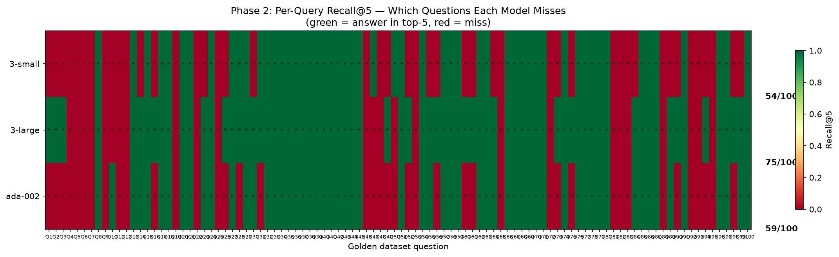 | Query × model heatmap | Hit (green) / miss (red) for all 100 queries per model | The right-edge column of common reds = the 22-query pipeline ceiling no model can break | 5
V8 | 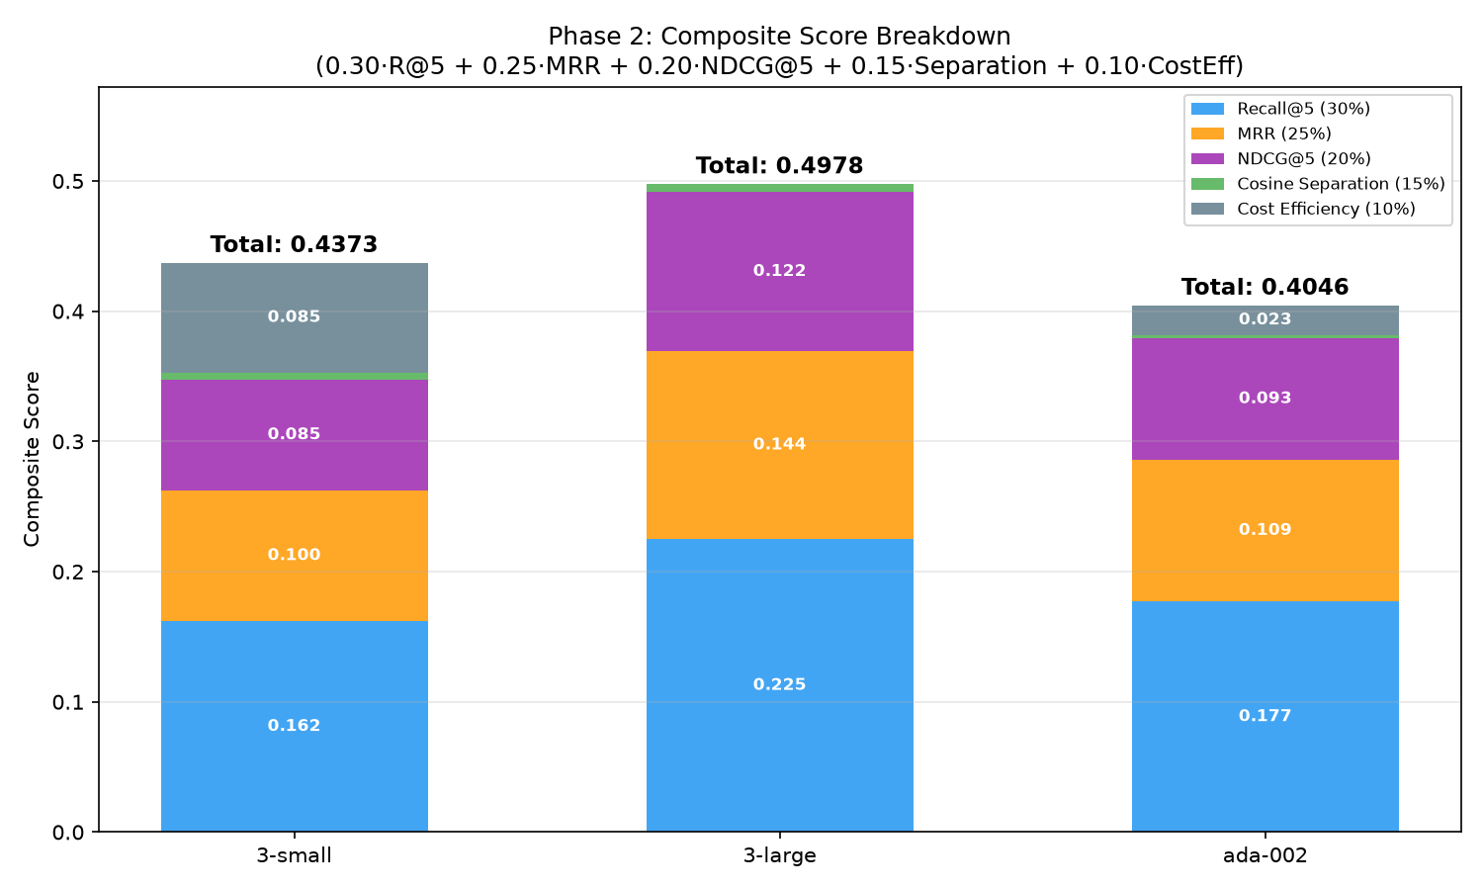 | Stacked bars | Weighted contribution of each criterion to the composite score | Where each model's rank comes from: quality blocks for 3-large, the cost block for 3-small | 7
V9 | 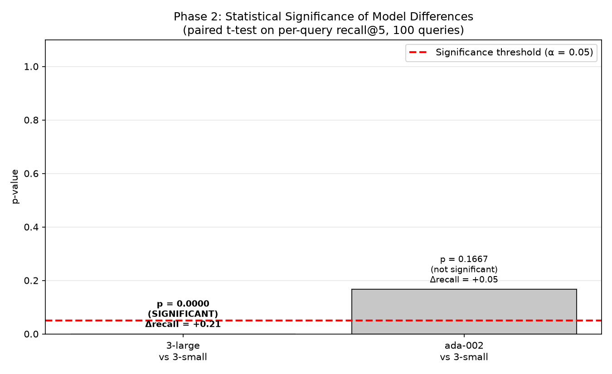 | Bar chart vs α=0.05 line | Paired t-test p-values vs baseline (3-small) | 3-large's bar crashes through the threshold (p=1.2e-05); ada-002's stays above it (p=0.167) — the tie, made visible | 5

6.2 Quality-per-dollar framing (the operational verdict)
Model | Quality/(Recall@5per(Recall@5per/1k queries) | Verdict
3-small | 180.0 | Efficiency winner (~4.7× 3-large)
ada-002 | 39.3 | Dominated — 3-small's price with no significant quality gain
3-large | 38.5 | Premium — pay 6.5× for +21 pts Recall@5

Step 7 — Build the Weighted Scoring Matrix
Industry practice: encode the business priorities into explicit weights, score every candidate on every criterion, and show the sensitivity — if the winner flips when weights change, the decision is weight-driven, not data-driven, and must be stated as such.

Our matrix (weights reflect a quality-first RAG product)
Criterion | Weight | 3-large | 3-small | ada-002 | Normalization
Recall@5 | 0.30 | 0.75 | 0.54 | 0.59 | raw (max = 1.0)
MRR | 0.25 | 0.577 | 0.401 | 0.436 | raw
NDCG@5 | 0.20 | 0.611 | 0.426 | 0.466 | raw
Cosine separation | 0.15 | 0.042 | 0.035 | 0.016 | raw
Cost efficiency | 0.10 | 0.00 | 0.85 | 0.23 | 1 − price/max_price
Composite score | 1.00 | 0.498 🥇 | 0.437 🥈 | 0.405 🥉 | Σ weighted

Sensitivity analysis (the part most teams skip)
Cost weight | Winner | Implication
10% (ours) | 3-large | Quality-first products
30% | tie 3-large / 3-small | The pivot point
≥40% | 3-small | Volume/cost-driven products
Takeaway: the ranking is stable in quality dimensions (3-large leads every quality criterion) and flips only through the cost lever — so the real decision variable is the cost of a retrieval miss in your application, not the models.

Step 8 — Summary & Decision

Final scorecard
 | text-embedding-3-large | text-embedding-3-small | text-embedding-ada-002
Quality (Recall@5) | 0.75 | 0.54 | 0.59
Ranking quality (MRR) | 0.577 | 0.401 | 0.436
Statistical status vs 3-small | significantly better (p<0.0002) | baseline | tie (p=0.267)
Cost / 1M queries | $19.50 | $3.00 | $15.00
Efficiency (quality/$) | 38.5 | 180 | 39.3
Storage (1,269 chunks) | 15.6 MB | 7.8 MB | 7.8 MB
Verdict | Default choice — quality-critical RAG | Scale choice — behind a reranker | Retire — Pareto-dominated

Decision (with conditions)
- Default: text-embedding-3-large for the capstone pipeline — quality-critical RAG where a retrieval miss degrades the answer, plus the strongest rank-1 behavior (+62% relative Hit@1)
- Scale path: text-embedding-3-small + reranker — if a cross-encoder recovers even half the 21-pt gap, it beats paying 6.5× per query; this is the designated Phase 3 experiment
- Never: ada-002 for new builds — statistically tied with 3-small at 5× the price, and its compressed cosine distribution (σ≈0.015) makes threshold-based filtering unreliable
- Any model migration = full re-embed + re-tune — cosine scores are not comparable across models (ada-002's 0.88 ≈ 3-series' 0.76)

